# DEEP LEARNING

<https://ch.mathworks.com/discovery/deep-learning.html>

Deep learning is a machine learning technique that teaches computers to do what comes naturally to humans: learn by example. Deep learning is a key technology behind driverless cars, enabling them to recognize a stop sign, or to distinguish a pedestrian from a lamppost. It is the key to voice control in consumer devices like phones, tablets, TVs, and hands-free speakers. Deep learning is getting lots of attention lately and for good reason. It’s achieving results that were not possible before.

In deep learning, a computer model learns to perform classification tasks directly from images, text, or sound. Deep learning models can achieve state-of-the-art accuracy, sometimes exceeding human-level performance. Models are trained by using a large set of labeled data and neural network architectures that contain many layers.

### **How does deep learning attain such impressive results?**

While deep learning was first theorized in the 1980s, there are two main reasons it has only recently become useful:

1. Deep learning requires large amounts of **labeled data**. For example, driverless car development requires millions of images and thousands of hours of video.
2. Deep learning requires substantial **computing power**. High-performance GPUs have a parallel architecture that is efficient for deep learning. When combined with clusters or cloud computing, this enables development teams to reduce training time for a deep learning network from weeks to hours or less.

### **Examples of Deep Learning at Work**

Deep learning applications are used in industries from automated driving to medical devices.

* Automated driving
* Aerospace and defence
* Medical research
* Industrial automation
* Electronics

## **How Deep Learning Works**

Most deep learning methods use **[neural network](https://ch.mathworks.com/discovery/neural-network.html" \t "_self)** architectures, which is why deep learning models are often referred to as **deep neural networks**.

The term “deep” usually refers to the number of hidden layers in the neural network. [Traditional neural networks](https://ch.mathworks.com/videos/getting-started-with-neural-networks-using-matlab-1591081815576.html) only contain 2-3 hidden layers, while deep networks can have as many as 150.

Deep learning models are trained by using large sets of labeled data and neural network architectures that learn features directly from the data without the need for manual feature extraction.

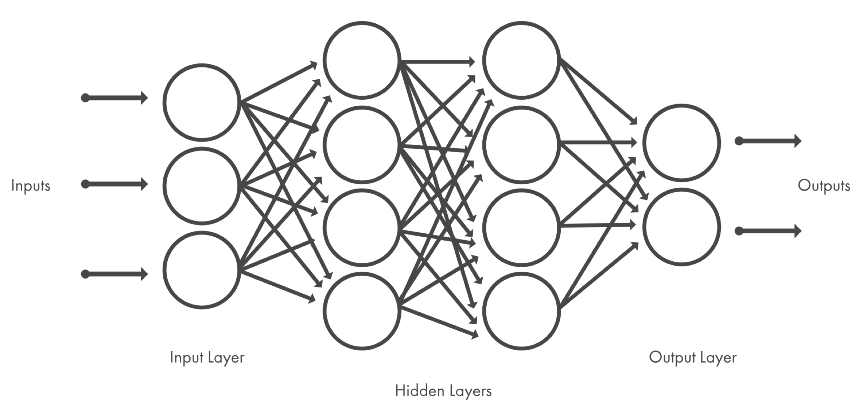

Figure 1: Neural networks, which are organized in layers consisting of a set of interconnected nodes. Networks can have tens or hundreds of hidden layers.

One of the most popular types of deep neural networks is known as [convolutional neural networks](https://ch.mathworks.com/discovery/convolutional-neural-network-matlab.html)**(CNN** or**ConvNet)**. A CNN convolves learned features with input data, and uses 2D convolutional layers, making this architecture well suited to processing 2D data, such as images.

CNNs learn to detect different features of an image using tens or hundreds of hidden layers. Every hidden layer increases the complexity of the learned image features. For example, the first hidden layer could learn how to detect edges, and the last learns how to detect more complex shapes specifically catered to the shape of the object we are trying to recognize.

### **What's the Difference Between Machine Learning and Deep Learning?**

Deep learning is a specialized form of machine learning. A machine learning workflow starts with relevant features being manually extracted from images. The features are then used to create a model that categorizes the objects in the image. With a deep learning workflow, relevant features are automatically extracted from images. In addition, deep learning performs “end-to-end learning” – where a network is given raw data and a task to perform, such as classification, and it learns how to do this automatically.

Another key difference is deep learning algorithms scale with data, whereas shallow learning converges. Shallow learning refers to machine learning methods that plateau at a certain level of performance when you add more examples and training data to the network.

A key advantage of deep learning networks is that they often continue to improve as the size of your data increases.